Vector search –
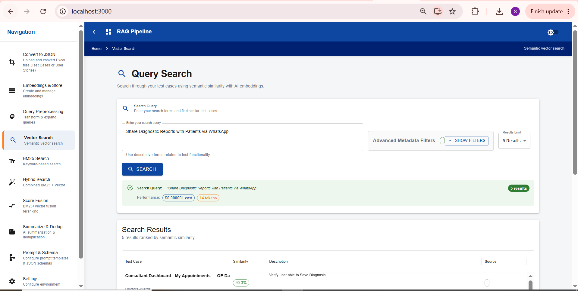

Langfuse trace logs-
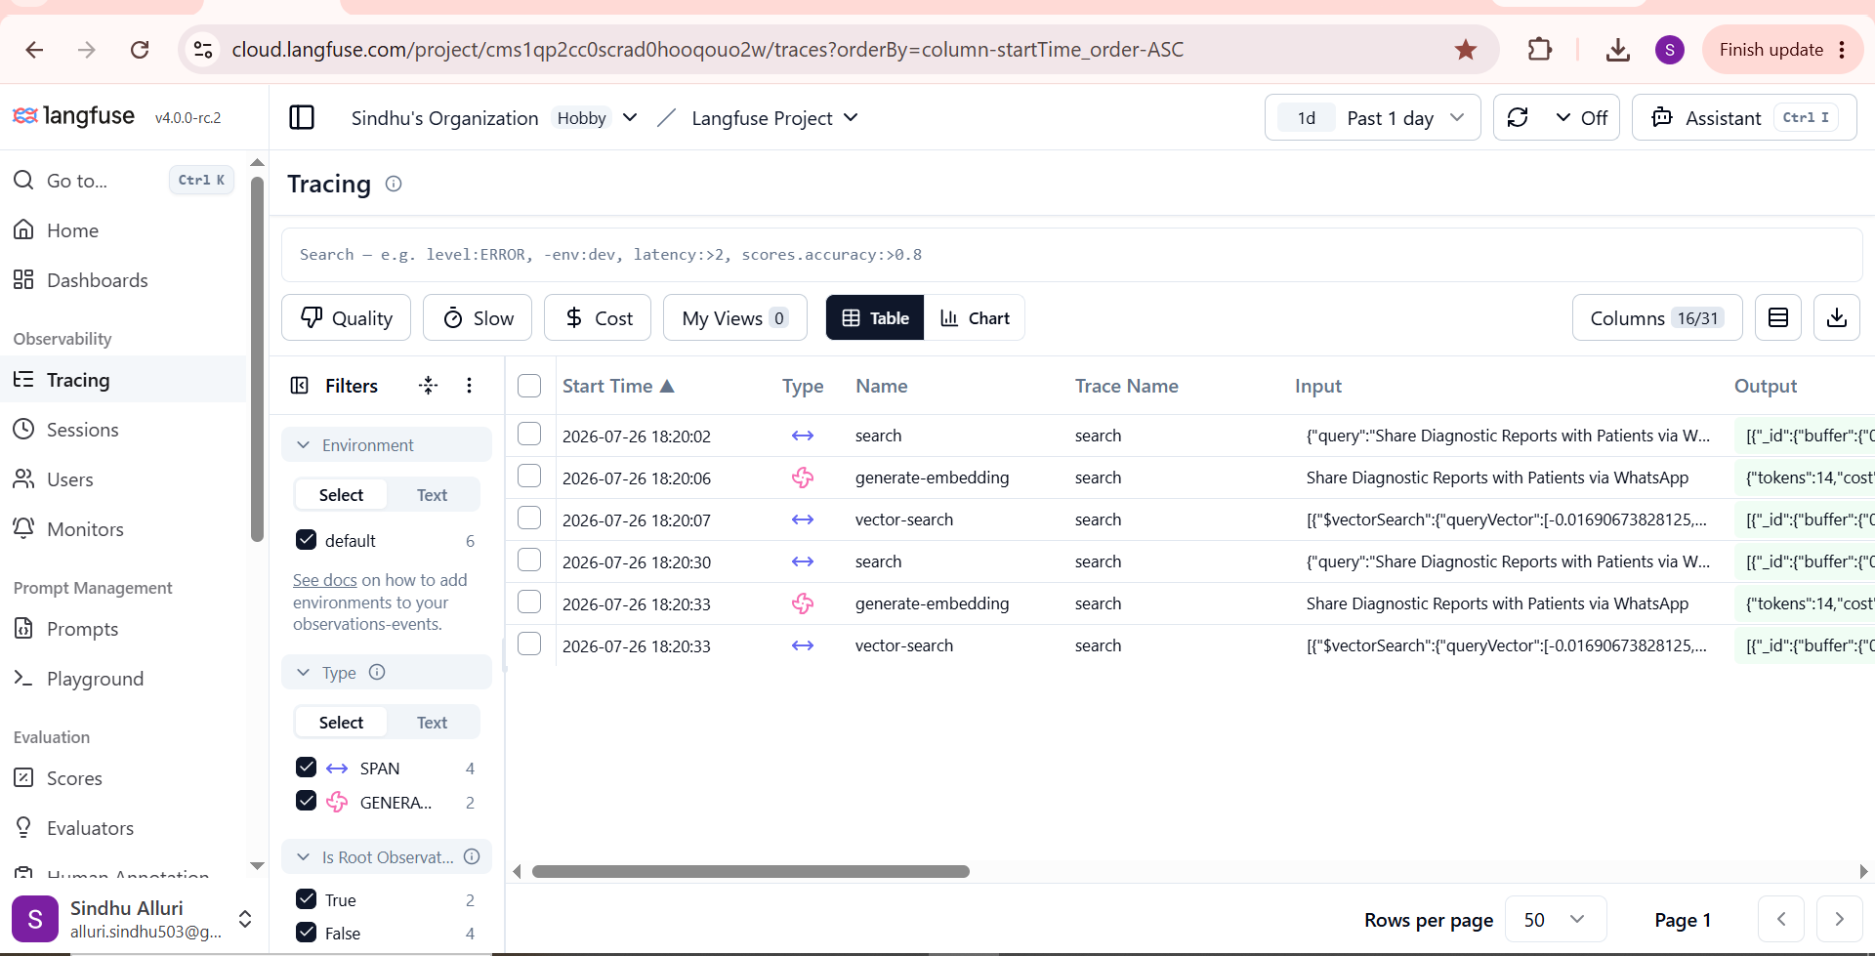

Prompt used–
Implement the tracing from lanfuse code for BM25 search and Hybrid search ,similar to the vector index search in code if not there already.keep the existing functionality as -is
BM25 search-
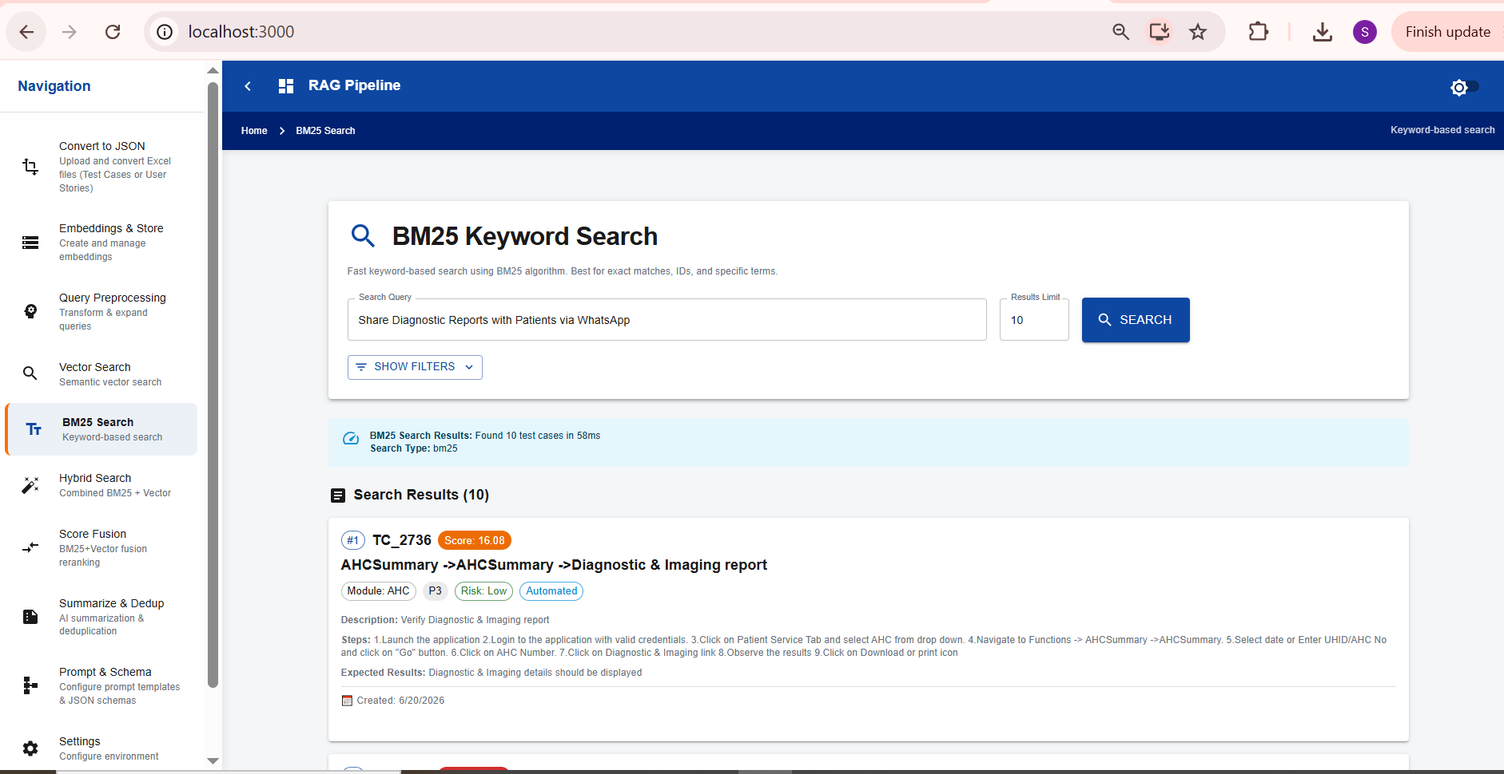
Langfuse trace logs-
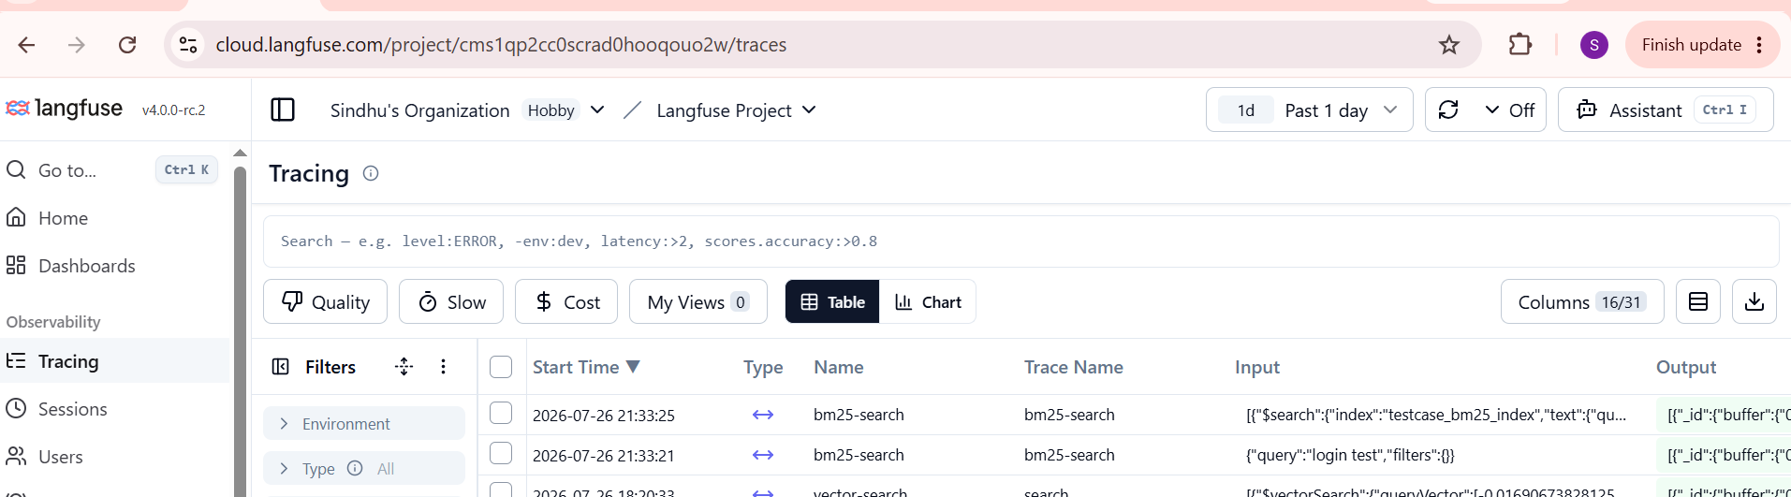

Hybrid search-
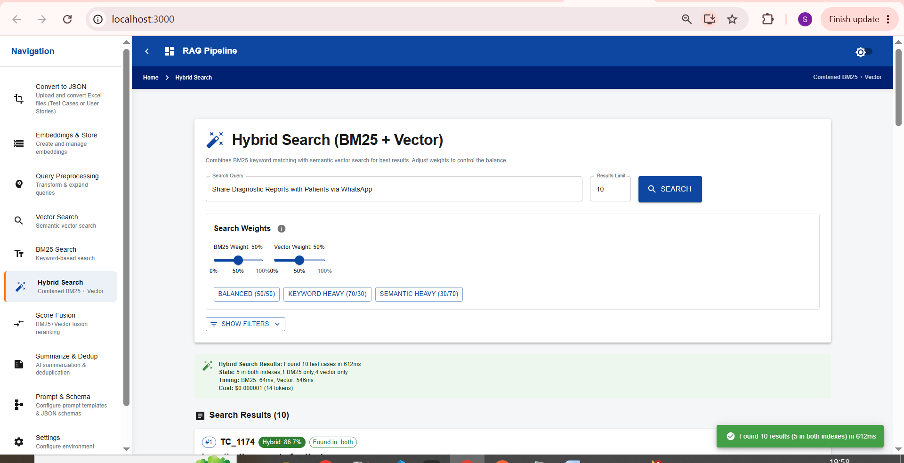
Langfuse trace logs-

